**Project report**

Liu Yuxin|lyxlyc2004@163.com|e1308816@u.nus.edu

**Intro**

In this document, I will be using the export data of Rep. Korea (“Korea” in the rest of the passage) from 2017-2022 to forecast the annual export values of Korea in 2023-2025. After briefly introducing my methodology, I will be showing my R code along with the data outcome and visualizations.

**Methodology**

The total value of export of a country is often related to factors such as partner countries’ business cycles, policies, and so on. Data such as PMI and FX are often used to forecast short-term export value. However, in this task, I am aiming for a 3 years of out-of-sample forecast which is a very long period, making the forecast based on unstable variables such as FX more unreliable. Also given that detailed data on Korea’s partner countries is unavailable and export data often have strong seasonality, I will divide the export data with commodities categories and apply linear regression analysis on the MoM (month on month) of Korea’s export value.

The data source is the UN Comtrade database (<https://comtradeplus.un.org/TradeFlow>) because of its relatively comprehensive data. The coding language is R because I am more familiar with it than other languages such as Python.

**R Code & Findings**

文本

中度可信度描述已自动生成文本

低可信度描述已自动生成1. Data Processing

The files:

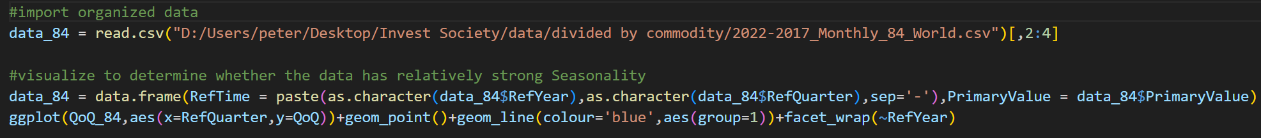Visualize the quarterly export data and confirm that the data has apparent seasonality.

Quarterly data:

2. Calculation and Forecasting

The files:



